

# External Documentation for Assignment 2

Contents

External Documentation for Assignment 2 1

Description 1

Nav Bar Section 2

Colours Section 2

Typography Section 3

Wireframes Section 4

Home Page 4

About Me 4

Projects 5

Services 5

Contact Me 5

Branding Section 6

Screenshots 6

Logo 7

## Description

The point of this project was to create a portfolio website to show off some of our work and have a responsive website. I used foundation as a framework to make the website.

## Nav Bar Section

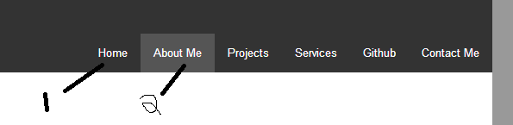

This is the navigation bar. It has links for all the different pages in my site. #1 is how a nav button looks normally and #2 is how a nav button looks when you hover over it.

## Colours Section

|  |  |
| --- | --- |
| Body Colour | #999999 |
| Main Content Area | #FFFFFF |
| Header & Footer & Nav Button | #333333 |
| Nav Button Hover | #444444 |
| Nav Button Current Page | #444444 |
| Nav Button Current Page Hover | #555555 |

## Typography Section

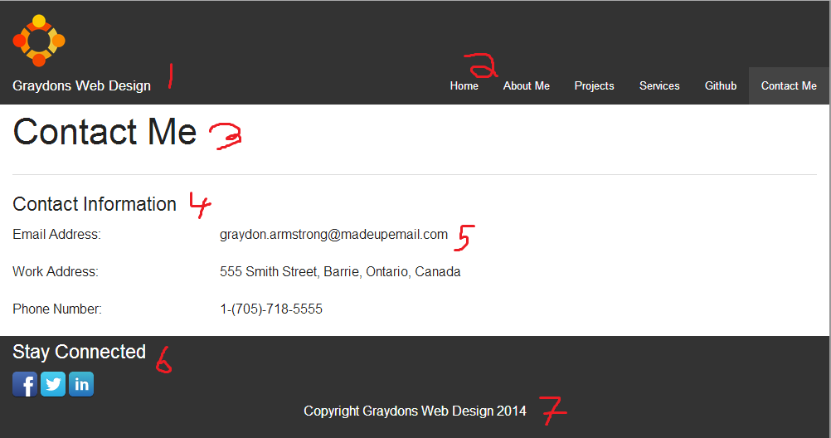

|  |  |  |  |
| --- | --- | --- | --- |
|  | Font | Size | Color |
| 1 | "Helvetica Neue", "Helvetica", Helvetica, Arial, sans-serif; | 1rem | #FFFFFF |
| 2 | "Helvetica Neue", "Helvetica", Helvetica, Arial, sans-serif; | 1rem | #FFFFFF |
| 3 | "Helvetica Neue", "Helvetica", Helvetica, Arial, sans-serif; | 2.125rem | #000000 |
| 4 | "Helvetica Neue", "Helvetica", Helvetica, Arial, sans-serif; | 1.125rem | #000000 |
| 5 | "Helvetica Neue", "Helvetica", Helvetica, Arial, sans-serif; | 1rem | #000000 |
| 6 | "Helvetica Neue", "Helvetica", Helvetica, Arial, sans-serif; | 1.125rem | #FFFFFF |
| 7 | "Helvetica Neue", "Helvetica", Helvetica, Arial, sans-serif; | 1rem | #FFFFFF |

## Wireframes Section

### Home Page

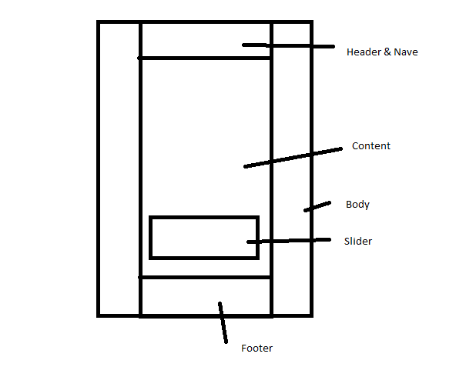

### About Me

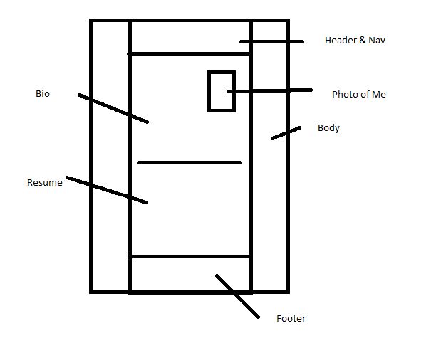

### Projects

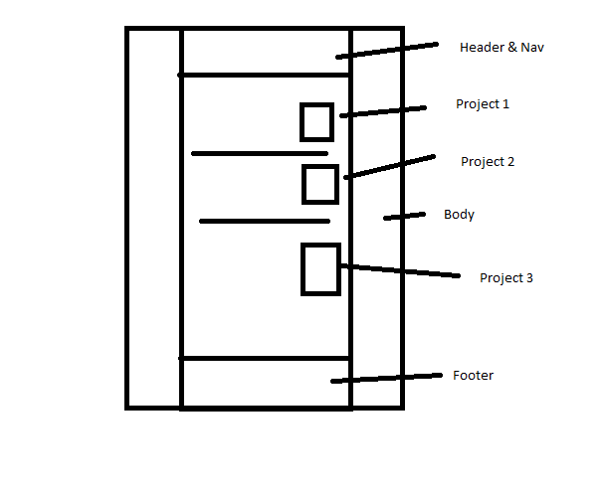

### Services

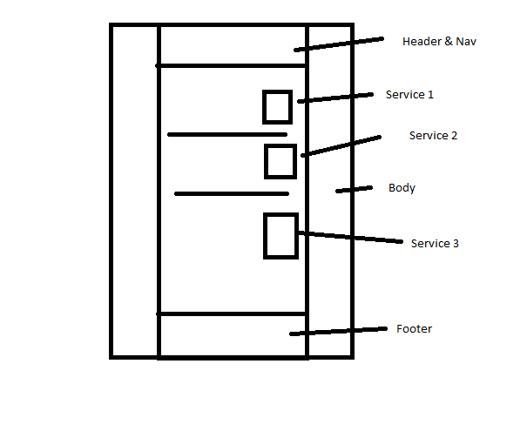

### Contact Me

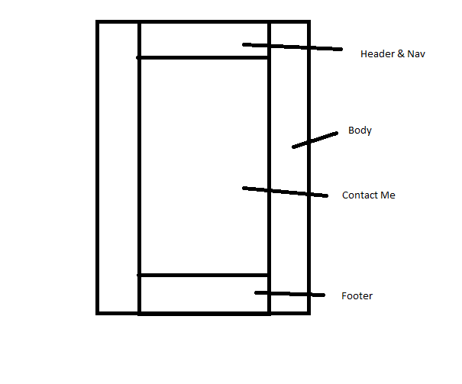

## Branding Section

### Screenshots

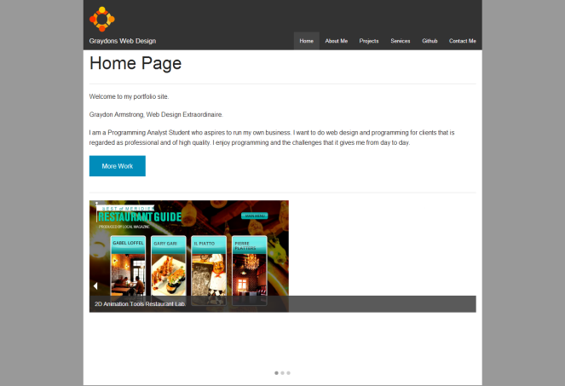 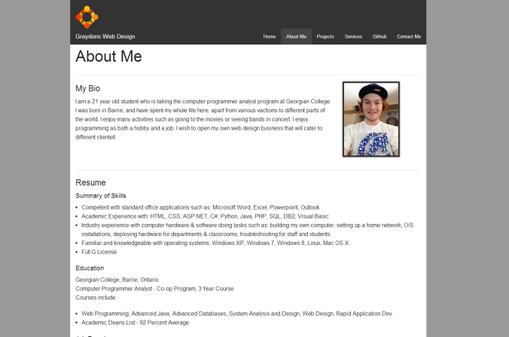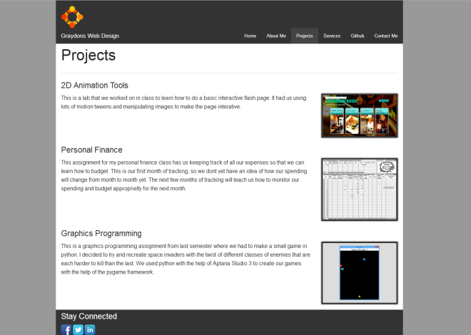 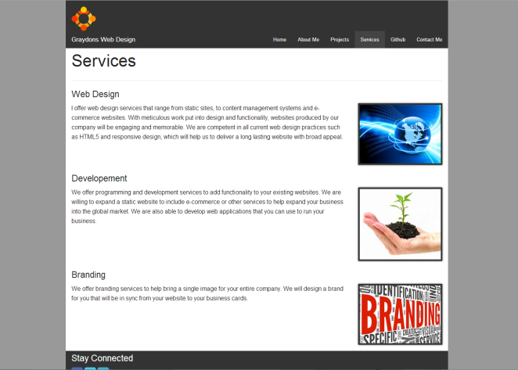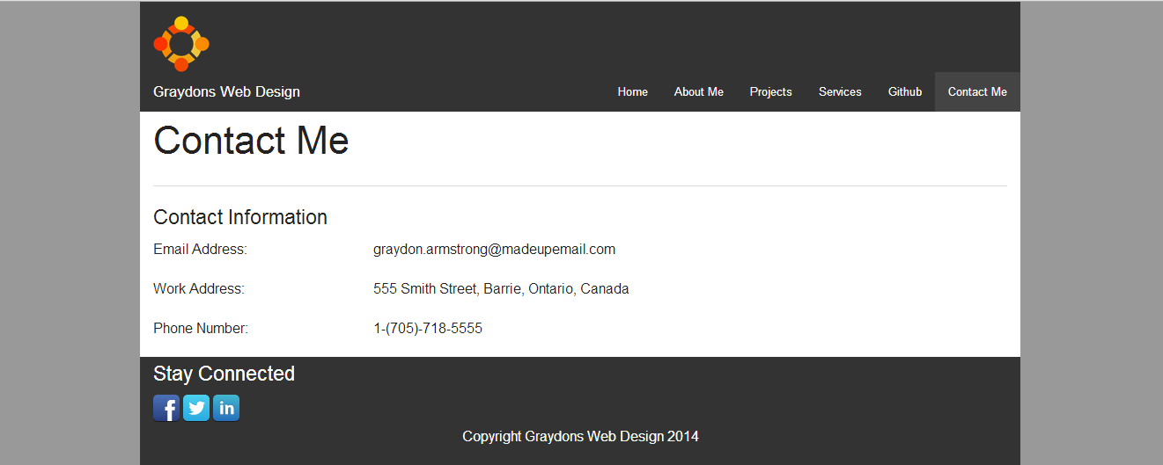

### Logo

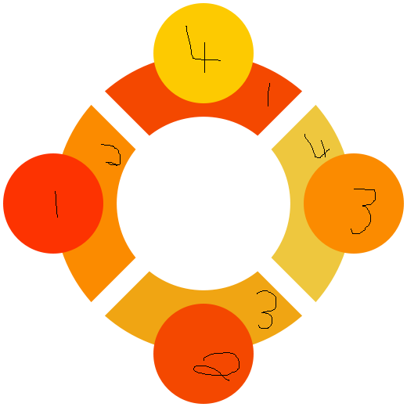

|  |  |
| --- | --- |
| Number | Hex |
| 1 | #FD3301 |
| 2 | #F44800 |
| 3 | #FB8B00 |
| 4 | #FDCA01 |